

SchoolSurvey Deployment Guide

Author: Catherine

Contents

Prerequisites 2

Upload files of data structure to OneDrive 2

Azure 5

PowerApps 8

Flow 11

Customized component 12

Power BI 12

Prepare for Submitting to app source 12

# Prerequisites

1. Sign up for OneDrive for Business.
2. An Azure subscription
3. Sign up for PowerApps.
4. Have a Power BI account and Power BI Desktop installed.
5. Get files of the project to your local machine. For now these files are in <https://canviz.visualstudio.com/_git/School%20Transformation%20Survey?path=%2FPackages>.

Files include:

|  |  |  |
| --- | --- | --- |
| Type | Name | Instruction |
| Folder | SchoolSurvey | This folder and contents in it need to be created or uploaded in OneDrive. |
| Zip | SchoolTransformationSurvey.zip | Contains app package and Flow which app used. |

Table:Files

# Upload files of data structure to OneDrive

There are two ways uploading files to OneDrive. If you have installed OneDrive app, and login with you organization account ,sync contents with your organization’s OneDrive, then only follow step 1 below, if not follow steps from step 2.

1. App: Run OneDrive app, it locates in the toolbar of your computer, Click the OneDrive icon, then click Open Folder,

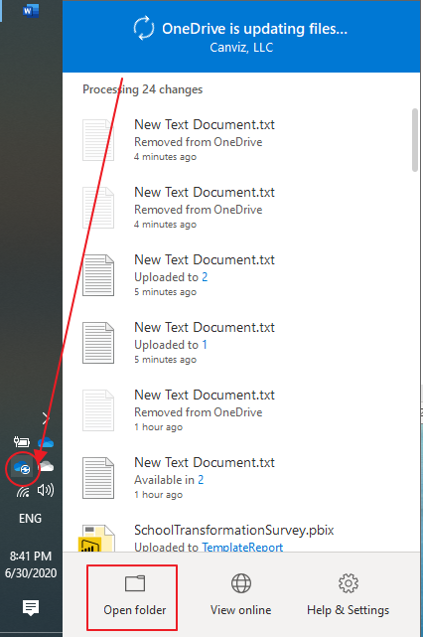

you’ll open a OneDrive folder which corresponding to the same content in OneDrive website. Copy the SchoolSurvey folder from the project files you got to the OneDrive folder, just wait for a few minutes, it’ll complete syncing.

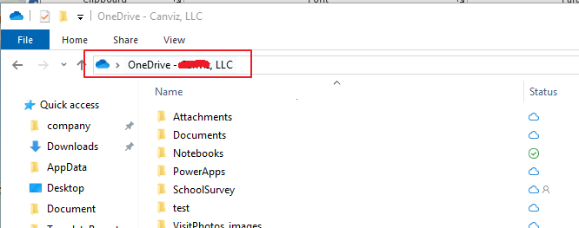

1. Web: Login to OneDrive, and go to My Files

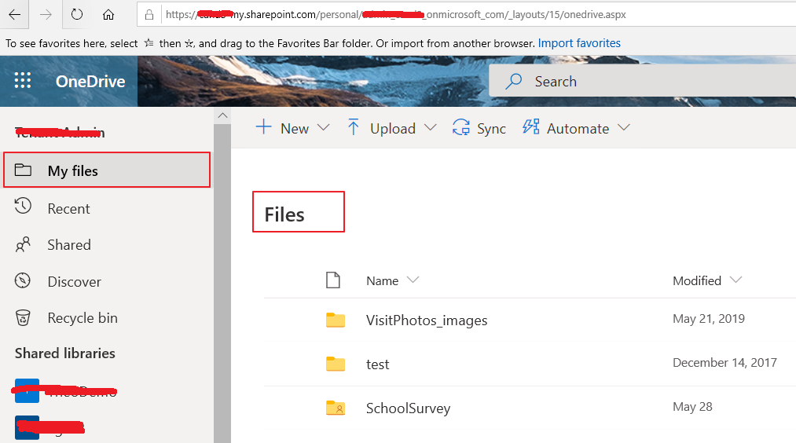

1. In My Files, Click the chevron beside menu New then select Folder to create root folder for the app, set a name and create. You’d better name it “SchoolSurvey” just like in Table:Files

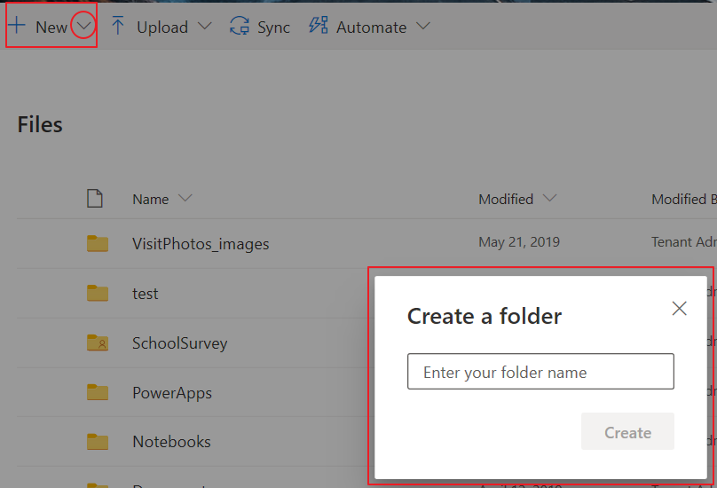

1. Open the folder you created, Click the chevron beside menu Upload then select Folder, you’ll see folder dialog. Find the project files you got, and go to SchoolSurvey folder, select AppData folder, then click button “Select Folder”. After uploading finished, open the AppData in OneDrive, make sure everything in this folder is uploaded.

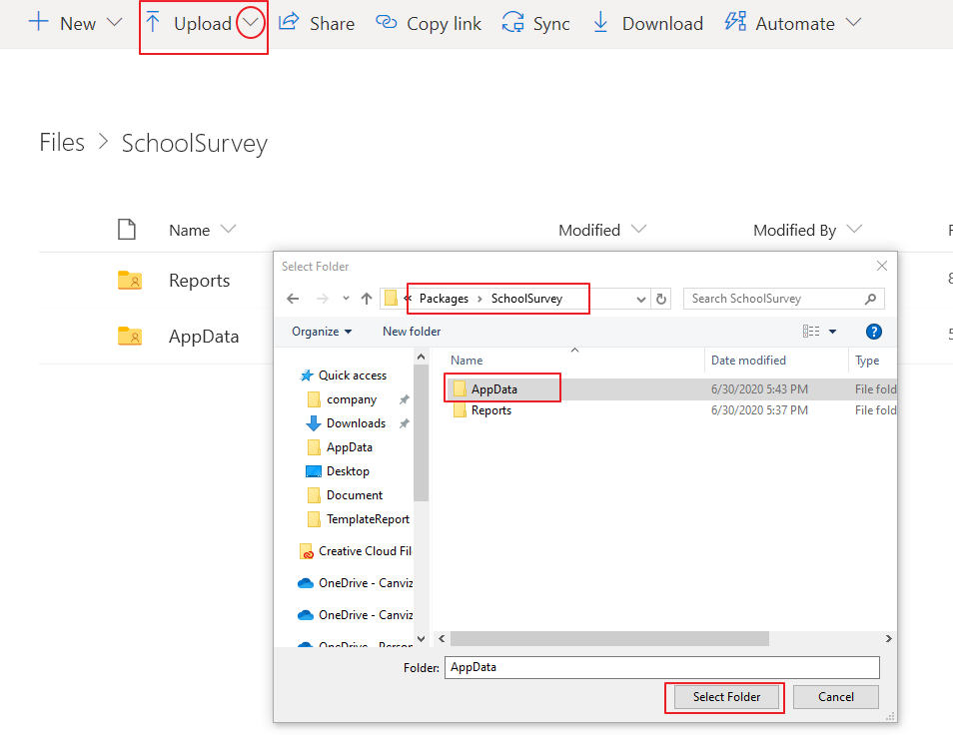

1. Go back to the root folder you created, create a new folder name it “Reports” , Open “Reports”, Upload “District” and “TemplateReport” folders from “SchoolSurvey->Reports” in the project files.

NOTE: You can not upload “Reports” folder directly, since OneDrive seems not support upload folder with subfolders.

NOTE: **Please remember the path of the files that you created or uploaded, you are gonna use it in the following steps.**

# Azure

Create admin group in Azure Group management for administrators of the app.

1. Login to Azure portal. <https://portal.azure.com>
2. Go to Azure Active Directory

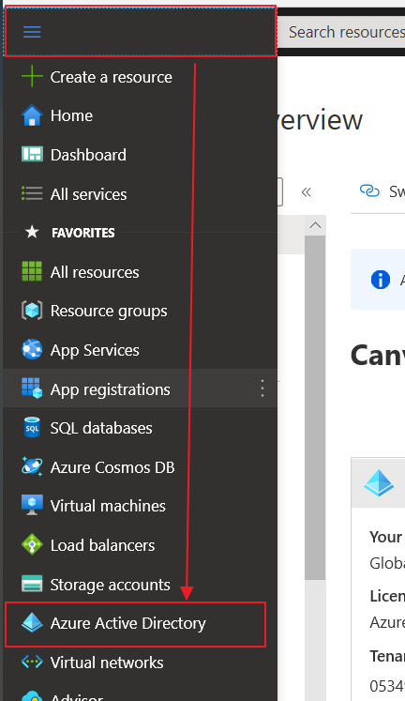

1. Go to Groups and click New group

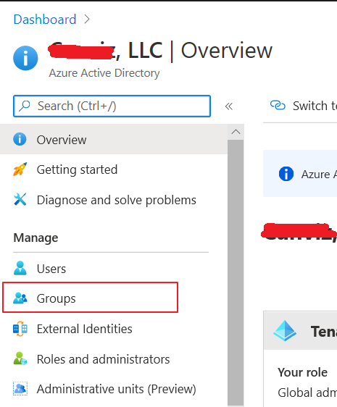 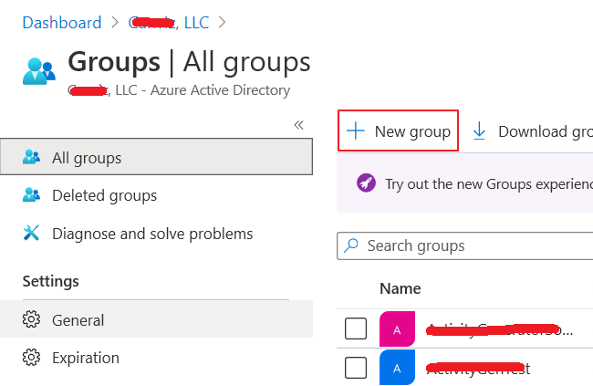

1. Create new group, Set Group type to “Security”, input Group name “SchoolSurveyAdmin”, input description if you want. You can also add members to this group in this dialog or add after creating done.

Note: You’d better keep the Group name be “SchoolSurveyAdmin”, otherwise you’ll have to update it in PowerApps.

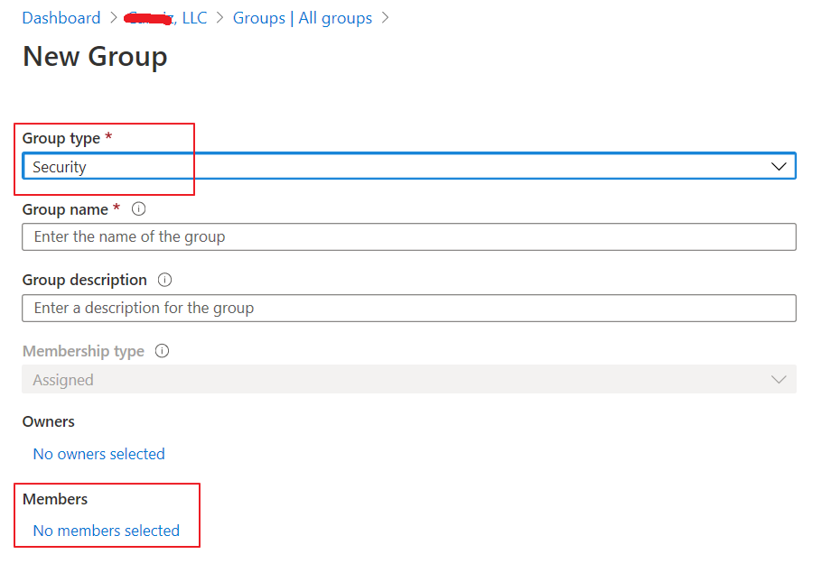

1. Add members to the group you created. If you don’t add members when you create group. Go to group list, search and find the group, go into this group and click Members

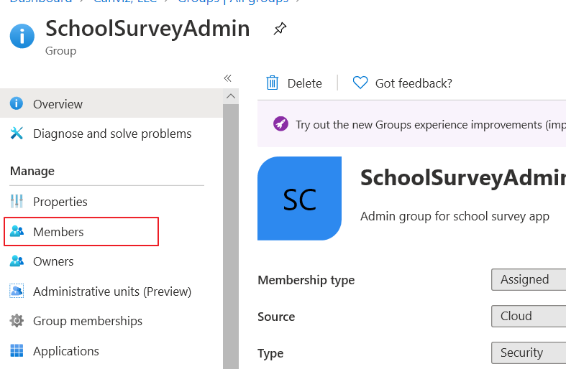

Search or select a member in your organization to add.

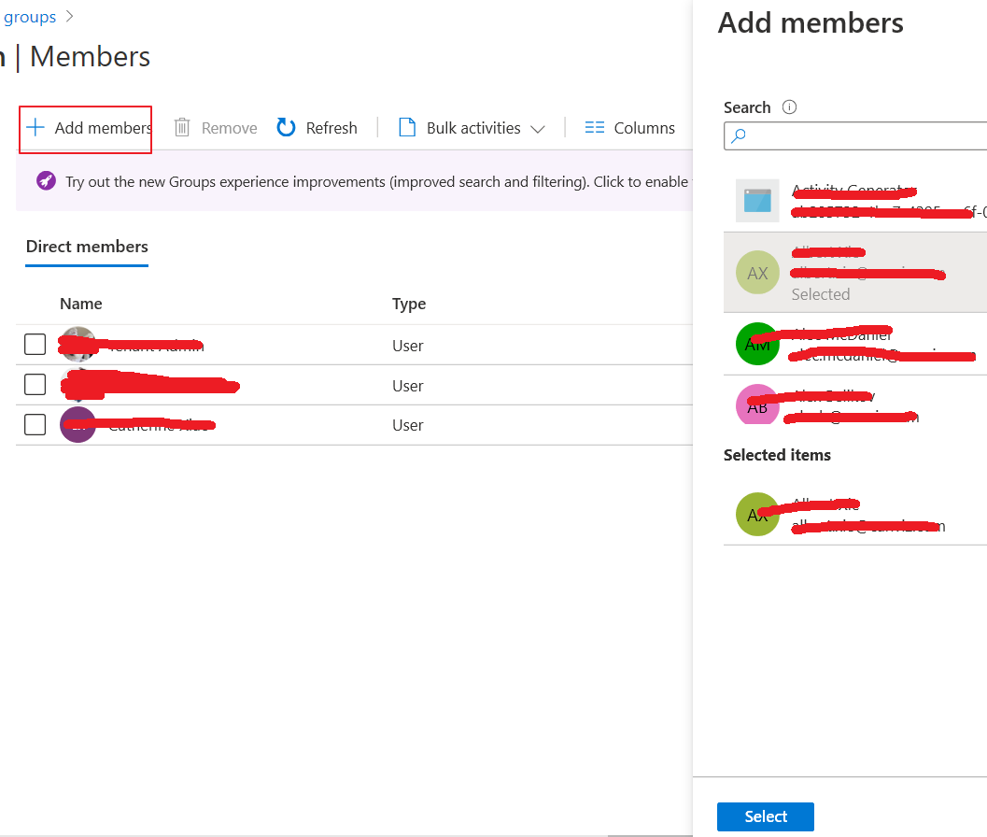

# PowerApps

1. Login to PowerApps. <https://make.powerapps.com> , go to Apps.
2. Import canvas app above Apps list.

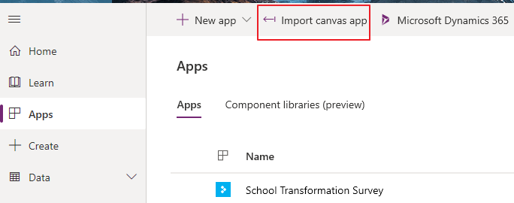

1. Upload zip file from project files, then click Import in the bottom right corner.

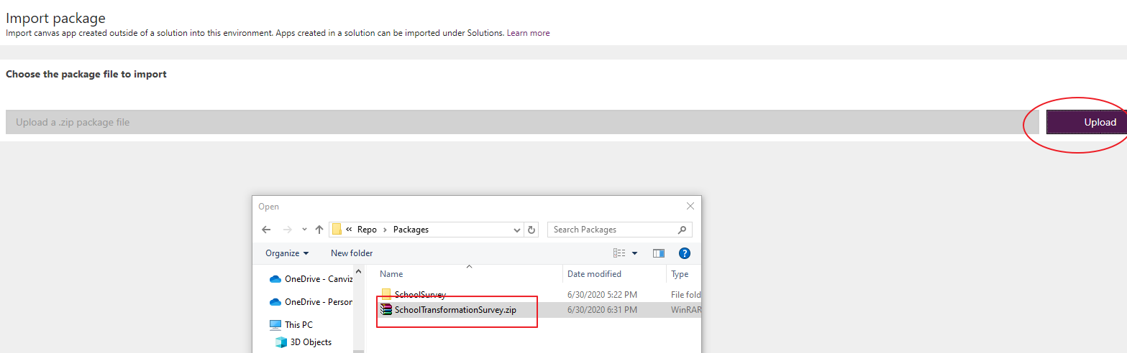

1. Go back to Apps list, find the app you imported, click Edit.

Issue: Not sure the customized component(Copy to Clipboard) is in it.

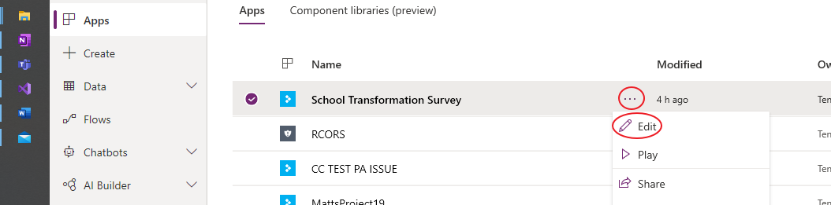

1. In the process of opening the app, it probably prompt warning dialog, please just open the app. Wait for a few minutes, you’ll see edit interface. Select App, In formula bar, select OnStart, then stretch input area behind fx like below.

There are five variables need to be set, input proper value in double quotes.

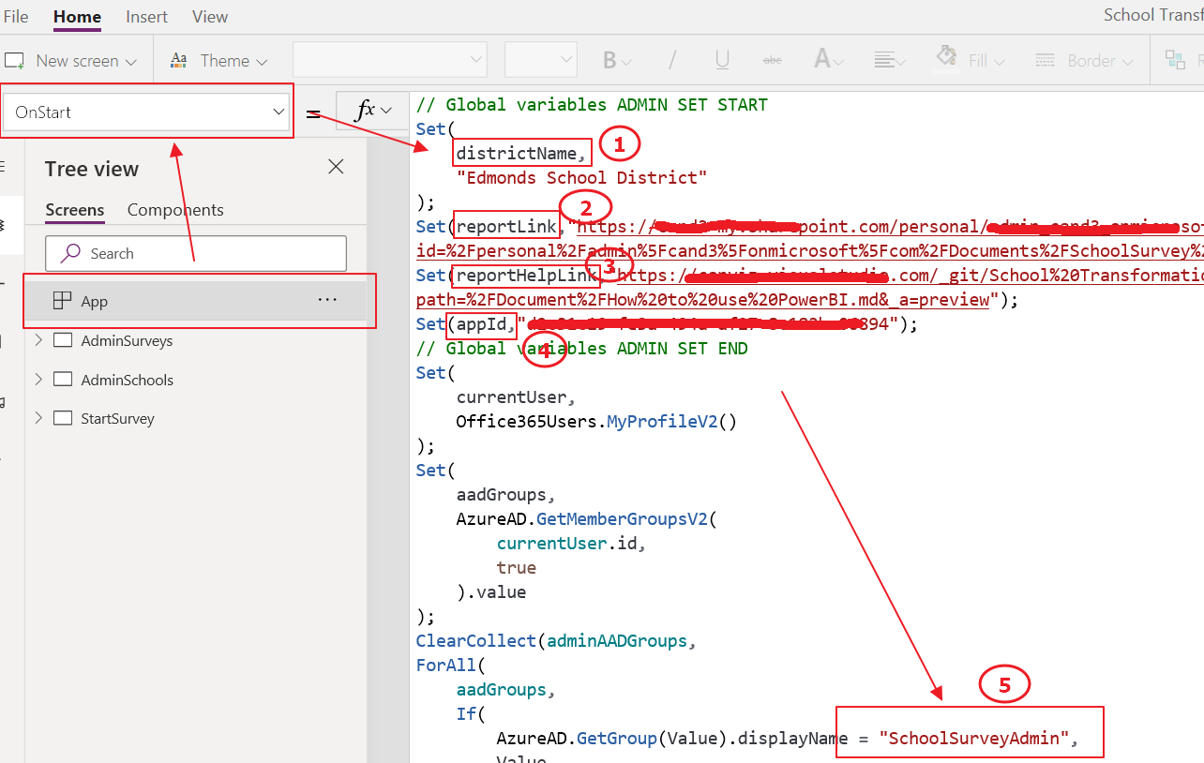

#1: districtName: Input the district name of schools

#2: reportLink: Go to OneDrive online, copy the link of Power BI template file,then paste the link to reportLink.

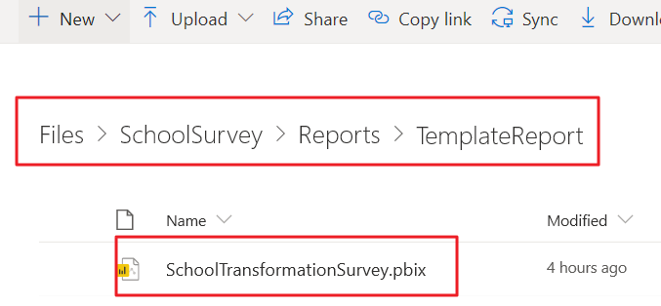

#3: reportHelpLink: Copy and paste the link of **How to use Power BI**.

#4: appId: Go to Apps list of PowerApps, find the app you are editing, click Detail.

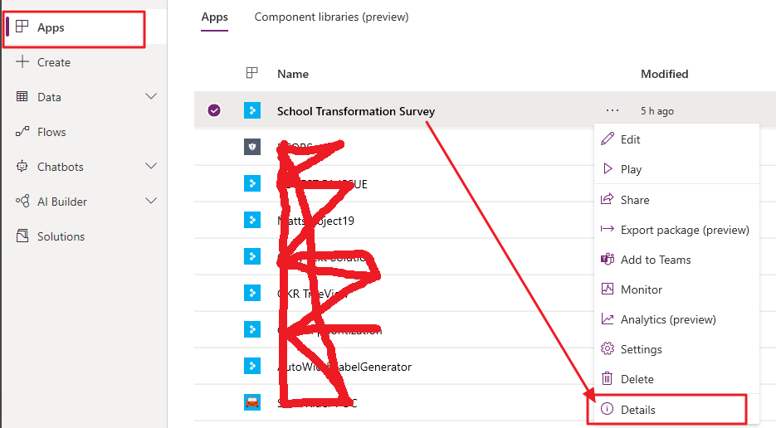

You can get the app id here, copy and paste it.

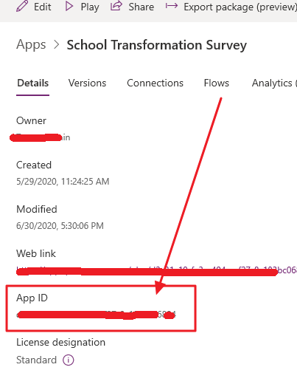

Issue: Not sure if submitting to app source, the app id should change. If change, the app id should use formula(connector) to get.

#5: Name of admin group: If you created the admin group using the name “SchoolSurveyAdmin”, you can pass this, if not, just copy the name you created to it.

# Flow

There are two flows servers the app, one is Instant type, the other is Scheduled type. The instant flow is packed into app’s package, scheduled one is not. TODO….

# Customized component

In surveys list in the app, we use a customized component to implement copy the link of survey to clipboard. ISSUE. TODO…

# Power BI

Refer to “How to use Power BI”

# Prepare for Submitting to app source

1. App check: Done after code finished.
2. E2E function document.(Working….)
3. Follow the instruction to submit. <https://docs.microsoft.com/en-us/powerapps/developer/common-data-service/publish-app-appsource>